Weigh & Measure Form
Name:
Date:

BEFORE | Measurement (IN or CM) | AFTER | Measurement (IN or CM) | CHANGE
Chest |  | Chest
Stomach 1 |  | Stomach 1
Stomach 2 |  | Stomach 2
Belly Button |  | Belly Button
Hips |  | Hips
Leg Right |  | Leg Right
Leg Left |  | Leg Left
Arm Right |  | Arm Right
Arm Left |  | Arm Left

Weight  (optional) |  | Weight  (optional)

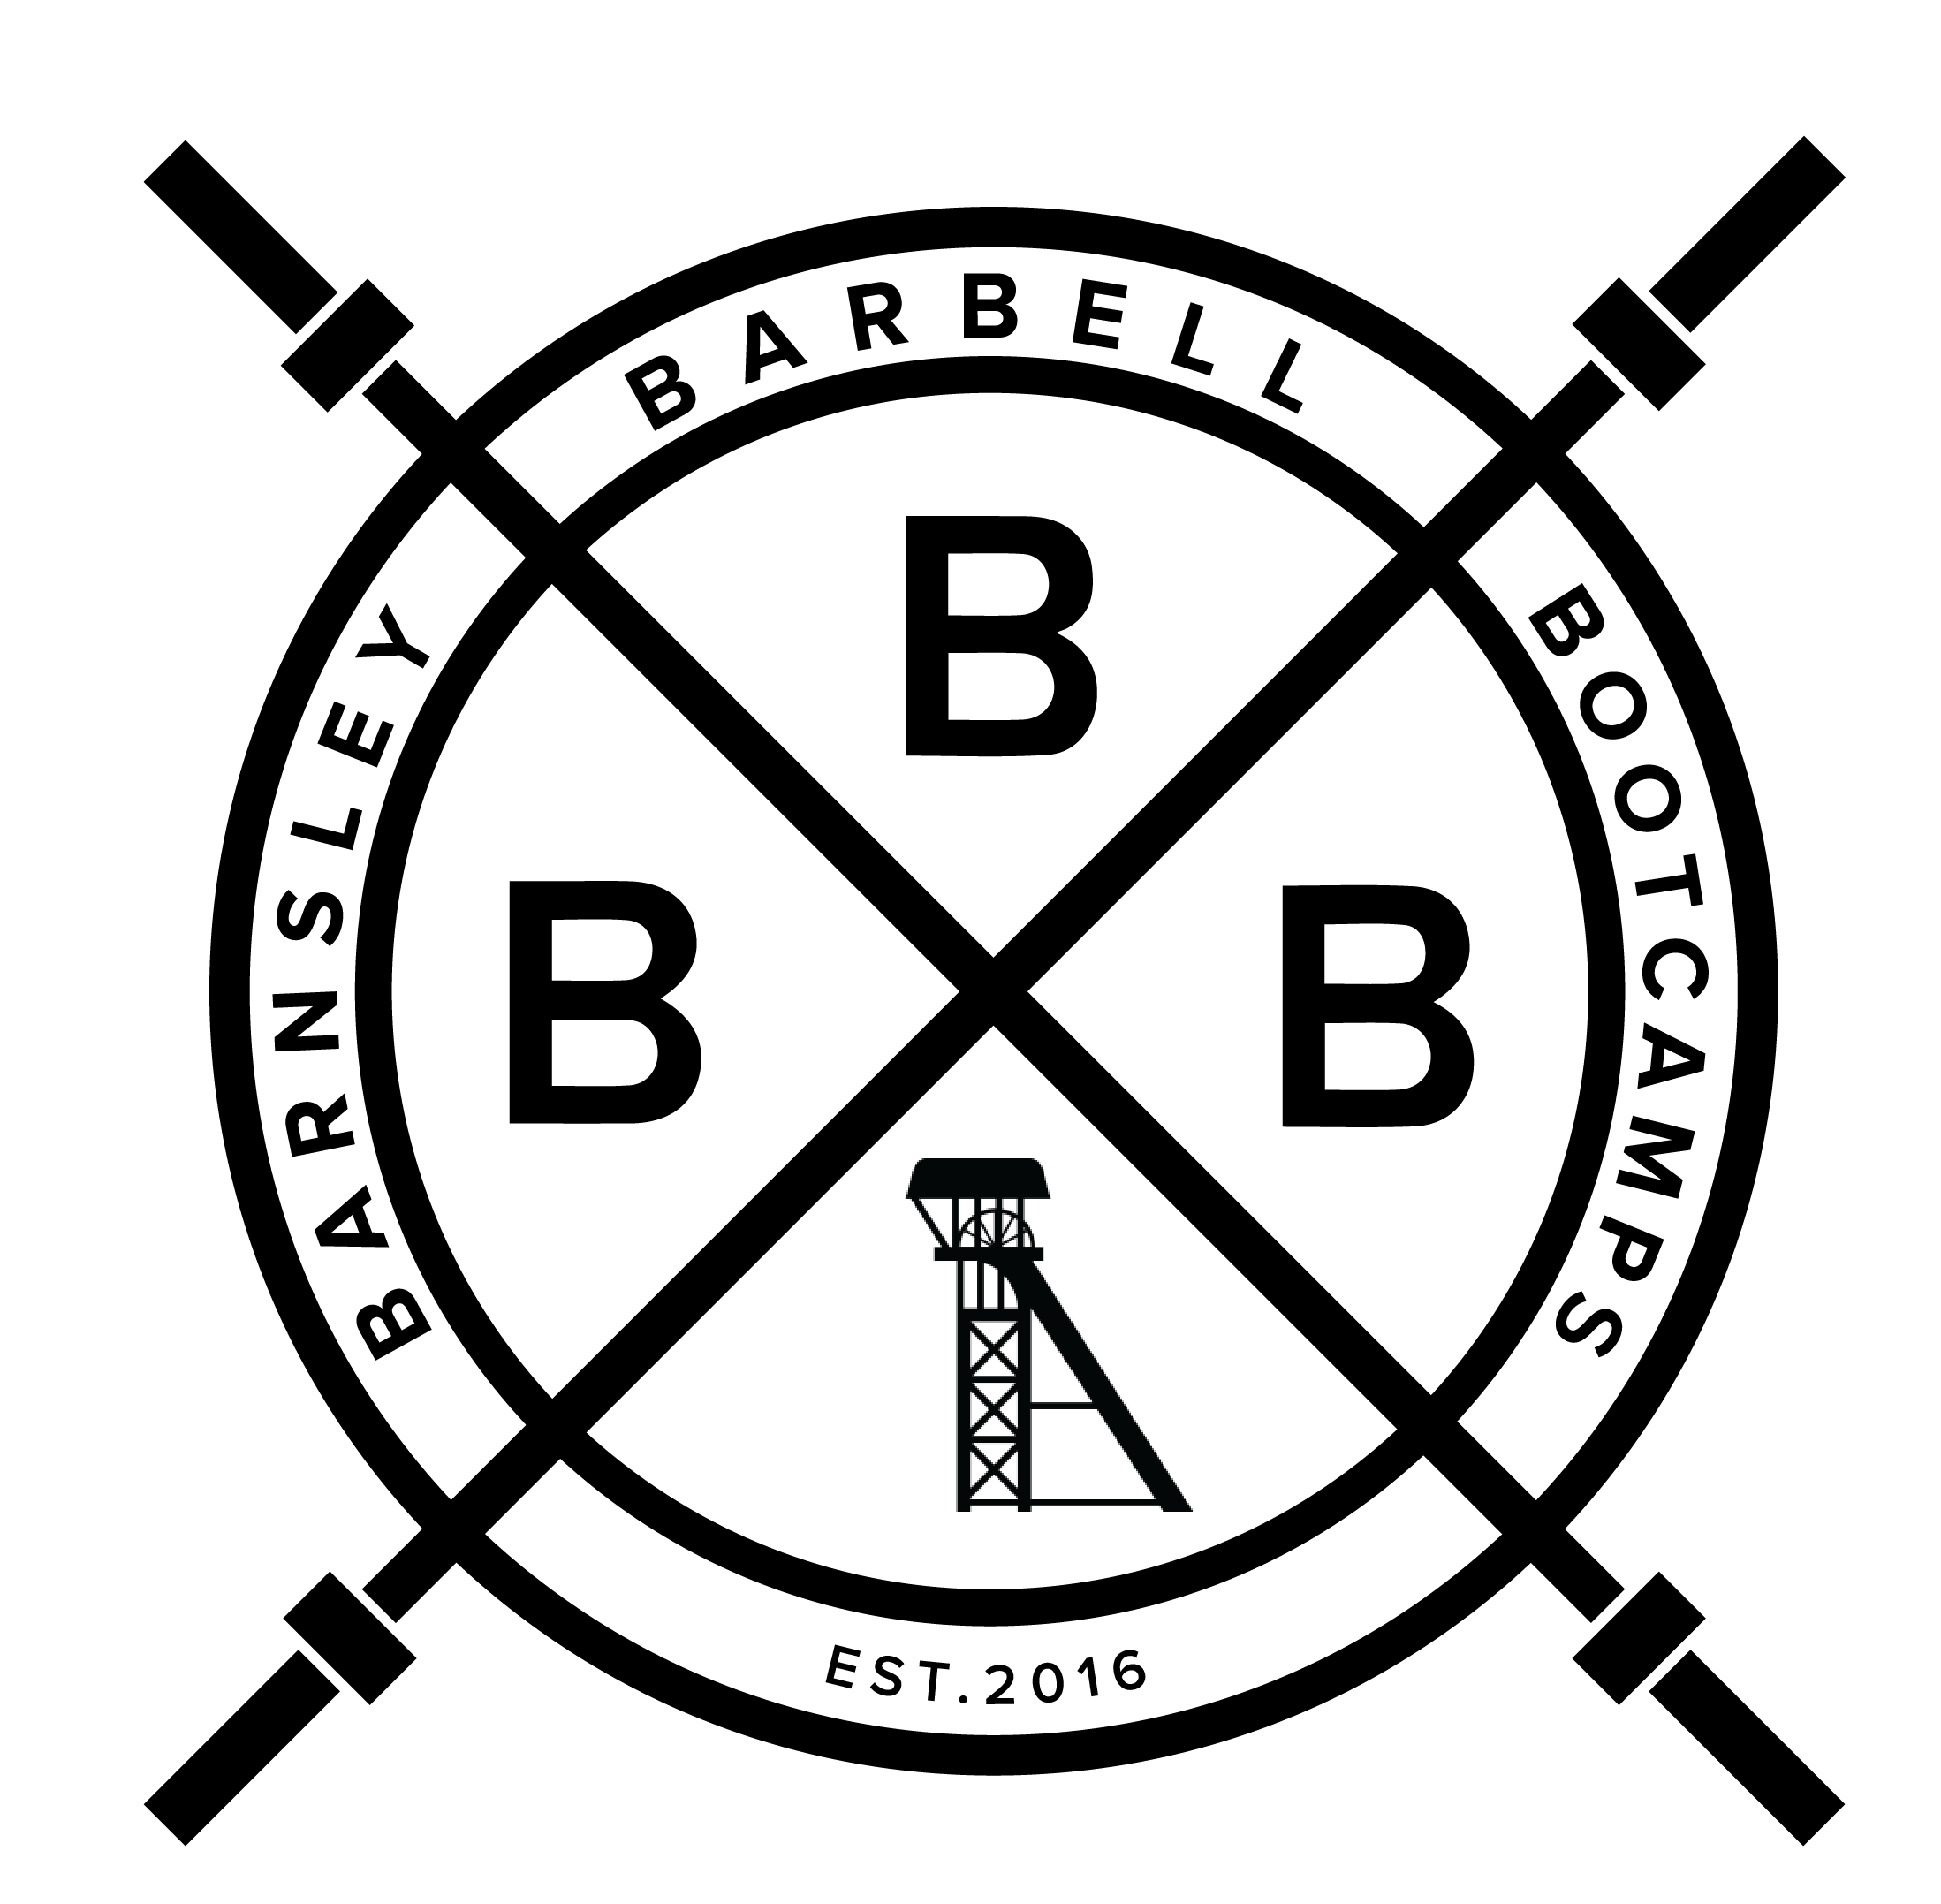

Type | How
Chest | Across the chest, inline with your nipples
Stomach 1 | Around 1 inch under the point where your chest finishes (or where the top abdominal muscle is)
Stomach 2 | The largest part of your stomach region between chest and hips
Belly button | Around your belly button
Hips | Poke your hip bones and measure around there – this maybe different to your underwear line / where your jeans sit
Leg - Right | The largest part of your thigh
Leg - Left | The largest part of your thigh
Arm - Right | The largest part of your upper arm
Arm - Left | The largest part of your upper arm
Weight  (optional)* | Weigh yourself on the same day of the week for the before and after. Do so with no clothes on. Do it in the morning AFTER you have used the bathroom and BEFORE consuming food or drink.

Please note: It is important for women to note that varying stages in their cycle can lead to different levels of body weight. We tend to recommend weighing yourself at roughly the same stage of your cycle e.g. every 4 weeks or 8 weeks.

Scale weight DOES NOT dictate progress. Please refer to our video in the Foundation Series where we cover this in further detail.

Photos | Please take photos from the front, back and both sides.
Clothed | Ensure you are wearing the same clothes for the before and after. Baggy clothing often doesn’t reflect changes in body shape, so we recommend wearing something fitted.
Less-clothed | We highly recommend taking some photos in your underwear. This is due to the fact you can see your entire body shape and the changes you have made. Whilst this can potentially cause some people to feel uncomfortable, just know that you have the power to make positive changes and you will do so during this challenge. This is one of the most accurate means of showing progress.

